**Day13**

**Archive & Compression**

**Three types of compression**

**Tar**

**gunzip**

**zip**

**1.using create the directory and change the directory and fallocate -l command using to mb creating and additional name also adding**

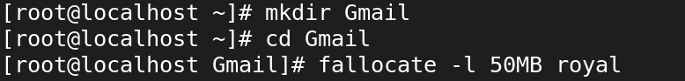

**2.And next to listing process**

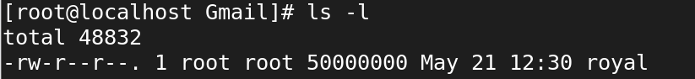

**3.Create the new achieve and ll means list command also using**



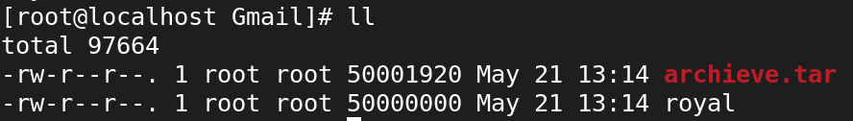

**4.using Extract file from the existing archive and ll means list command also using**

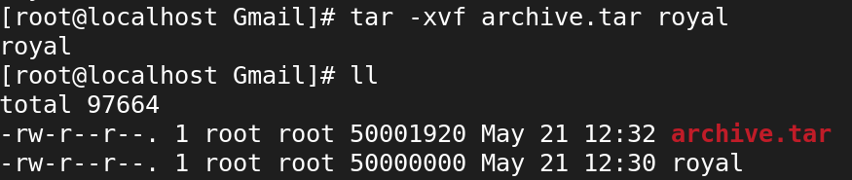

**5.create the compression to gunzip(gz),bunzip(bz2),normal zip(x2)of using the command**

**also mentioned**

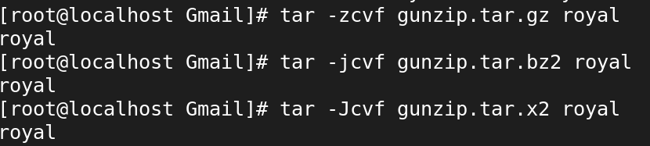

**6.using completed the compression and view the command also mentioned**

